The Grand old Duke of York

The Grand old Duke of York
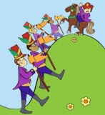
He had ten thousand men
He marched them up to the top of the hill
And he marched them down again.
When they were up, they were up
And when they were down, they were down
And when they were only halfway up
They were neither up nor down.

Humpty Dumpty
Humpty Dumpty sat on a wall,
Humpty Dumpty had a great fall.
All the Kings horses and all the Kings men,
Couldn’t put Humpty together again.

Baa Baa Black Sheep
Baa, baa, black sheep,
Have you any wool?
Yes, sir, yes, sir,
Three bags full;
One for my master,
And one for my dame,
and one for the little boy
Who lives down the lane.

Row, row, row your boat
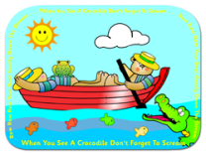
Row, row, row your boat
Gently down the stream,
Merrily, merrily, merrily, merrily,
Life is but a dream.
Row, row, row your boat
Gently down the stream,
If you see a crocodile, don’t forget to scream!

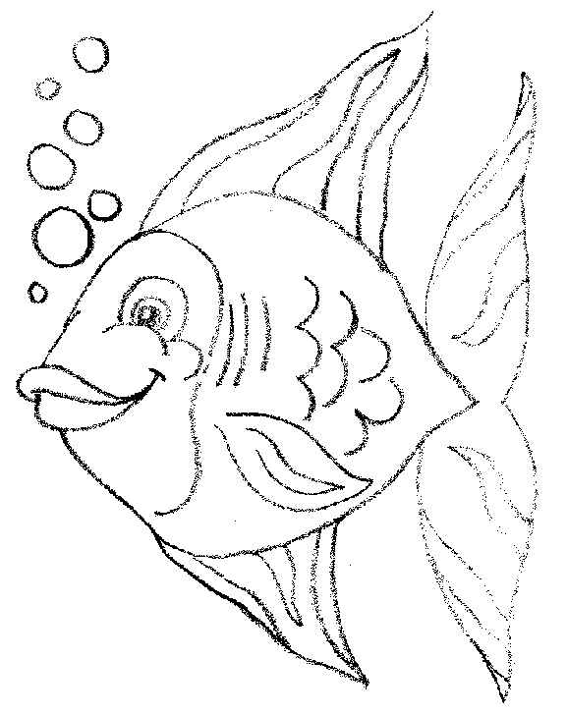

One, two, three, four, five
One, two, three, four, five,
Once l caught a fish alive.
Six, seven, eight, nine, ten,
Then l let it go again;
"Why did you let it go?"
"Because it bit my finger so."
"Which finger did it bite?"
This little finger on my right.

Polly put the kettle on
Polly put the kettle on,
Polly put the kettle on.
Polly put the kettle on,
We'll all have tea.
Sukey take it off again'
Sukey take it off again.
Sukey take it off again,
They've all gone away.
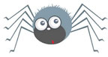
Incy Wincy Spider
Incy Wincy Spider climbed up the water spout.
Down came the rain and washed the spider out!
Out came the sunshine and dried up all the rain.
And Incy Wincy Spider climbed up the spout again!

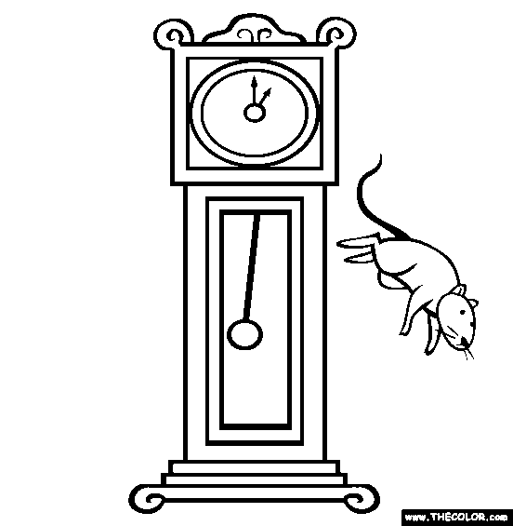
Hickory Dickory Dock

Hickory, dickory, dock,
The mouse ran up the clock.
The clock struck one,
The mouse ran down,
Hickory, dickory, dock

