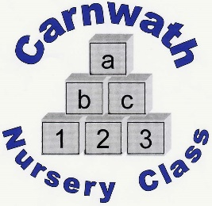
Is your child 2 years old?
- Do you live in the Carnwath area?

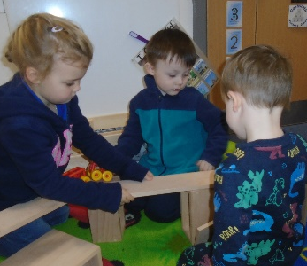
- Are you intending to register your child at Carnwath Primary Nursery Class?

- If so, we would like to invite you to attend a short play session with your child on:

Thursday 28th November 2019 from 3.15pm - 4.15pm

- Come along and meet the nursery staff
and engage in some fun learning activities!

**All application forms for nursery places must be submitted to
your first choice nursery by Thursday 30th April 2020 **

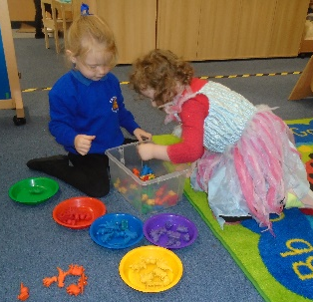
Address: Carnwath Primary School
White Craw Court
Carnwath
ML11 8GZ

If calling ask for: Lesley Stewart
Contact Number: 01555 840 263

