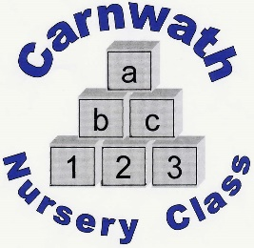
Is your child 2 years old?
- Do you live in the Carnwath area?

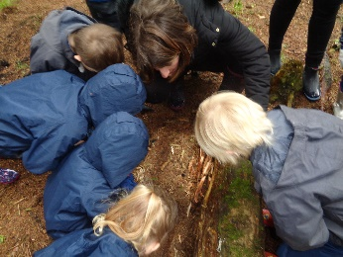
- Are you intending to register your child at Carnwath Primary Nursery Class?

- If so, we would like to invite you to attend
a short play session with your child on:

Tuesday 18th February 2020 from 3.15pm - 4.15pm

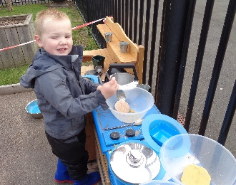
- Come along and meet the nursery staff
and engage in some fun learning activities!

- Carnwath Nursery Class can offer 1140 funded hours of Early Learning and Childcare throughout the school term for your child.

**All application forms for nursery places must be submitted to
your first choice nursery by Friday 28th February 2020 **

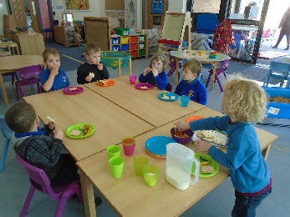
Address: Carnwath Primary School
White Craw Court
Carnwath
ML11 8GZ

If calling ask for: Lesley Stewart
Contact Number: 01555 840 263

