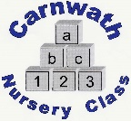
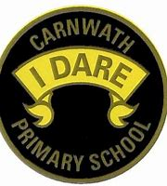
What is happening online this week?

Week Beg: Monday 23rd March, 2020
Subject | Day | Time | Website
P.E.  Joe Wicks | Mon - Fri | 9am | The Body Coach T.V. on YouTube
Glasgow Science Centre | Mon - Fri | 10am | Glasgow Science Centre website
Daily Phonics with Mr Mc  (This is a different curriculum but may be useful). | Mon – Fri | 11am | Mr Mc on YouTube
British Sign Language | Mon – Fri | 1pm | Natasha Lamb on YouTube
Fischy Music | Mondays | 11am | Fischy Music
History Lesson from secret WW2 bunker in Liverpool | Wednesday 25th March | 1pm | Western Approaches HQ Facebook page
Drawing – Draw with Rob Biddulph | Tues and Thurs | 10am | #DrawWithRob or Rob Biddulph on YouTube
Talk for Writing with Pie Corbett – radio blog | Mon - Fri | 9:30 to 10:30 | Radioblogging.net
Dough Disco (grab some play dough and have some fun)  And play based stories. | Mon – Fri | 9:30am  1pm | Spread the Happiness on YouTube

