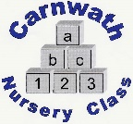
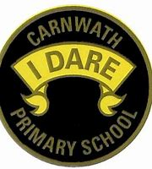
What is happening online this week?

Week Beg: Monday 30th March, 2020
Subject | Day | Time | Website
P.E. - Dance  Oti Mabuse | Mon - Fri | 11am | YouTube or Facebook
Science – Wildlife facts  Ben Rothery | Mon - Fri | N/A | benrotheryillustrator.co.uk
Phonics – Ruth Miskin | Mon – Fri | 9:30, 10 and 10:30am | YouTube
Story – David Walliams | Mon – Fri | 11am | www.worldofdavidwalliams.com
Maths – Carol Vorderman | Mon-Fri | N/A | www.themathsfactor.com
Crafts – Material Geeks from Lanark – daily challenges | Mon-Fri | N/A | Facebook
P.E. – Jonny Jump Start | Access everyday | N/A | www.jumpstartjonny.co.uk
P.E. - Go Noodle | Access everyday | N/A | www.gonoodle.com
Science – Maddie Moate from Cbeebies | Mon – Fri | N/A | YouTube
Cooking – with Jamie Oliver | Mon-Fri | 12pm | www.jamieoliver.com
Science – Zoo tours, safari parks | Access everyday | N/A | Chester Zoo  Blair Drummond Safari Park  Edinburgh Zoo  Paignton Zoo

