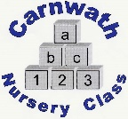
Carnwath Nursery Class
Home Learning – Week Beg: 8th June, 2020
Here are a few ideas of things to keep you busy at home this week. We are missing you all very much. Stay safe and keep washing your hands!
Our ‘Rhyme of the Week’ is ‘Five Currant Buns’. Please find a copy attached below.
Pebble Painting  Find some pebbles and, with some paints or pens, you can decorate them any way that you like. Get creative!  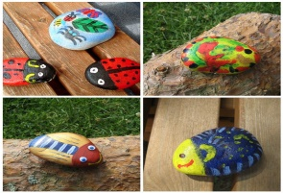 | Health and Well-being  Do some exercise to really get your heart going! Then get an adult to help you find your pulse on your wrist. Feel your heartbeat until it slows right down. | Relax Box  Fill a box full of things that help you to feel relaxed and calm. You might put in a small cuddly toy, a smooth pebble or a squishy ball…..  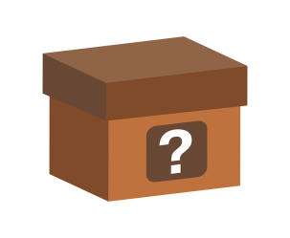 | Rainbow Dish  Help to make a healthy meal or snack using different coloured fruit and vegetables.  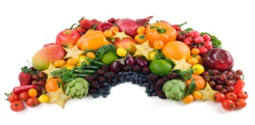 | Family Portrait  Draw a ‘Family Portrait’ with all your family members and include your pets too!  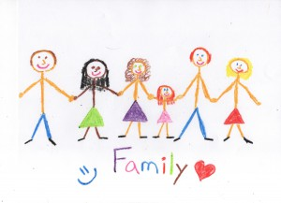
Mindfulness  Chill on a beanbag or cushion and listen to some calm, relaxing music. Remember to practise your big breaths in and out. | Dotty Painting  Use the tip of some cotton buds and some paint to create your very own dotty picture. You could draw an outline of a flower or something similar and fill it in with lots of different coloured dots. | Go, wild!  Sign up to the Scottish Wildlife Trust ‘30 Days Wild Challenge’ for free.  https://scottishwildlifetrust.org.uk | Fine Motor Skills  Help to spread butter onto a piece of bread or toast. Add a few ‘sprinkles’ if you have them, just for fun!  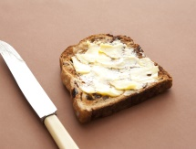 | Baking  Can you bake some of your very own delicious buns? Count how many you have made before you eat them all up!  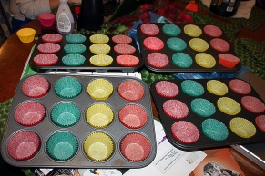
Online resources: www.oxfordowl.co.uk www.familiesonline.co.uk www.parentclub.scot
www.topmarks.co.uk/maths-games/3-5-years/counting www.playscotland.org Percy the park keeper – youtube

Five Currant Buns
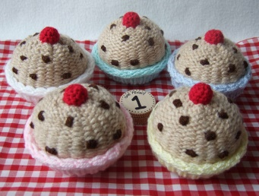

Five currant buns in a baker’s shop,
Round and fat with a cherry on top,
Along came a boy/girl with a penny one day,
Bought a currant bun and took it away.

Four currant buns in a baker’s shop……
Three currant buns in a baker’s shop……
Two currant buns in baker’s shop……..
One currant bun in a baker’s shop……

