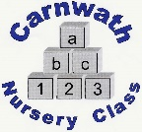
Carnwath Nursery Class
Home Learning – Week Beg: 11th May, 2020
Here are a few ideas of things to keep you busy at home this week. We are missing you all very much. Stay safe and keep washing your hands!
Our ‘Rhyme of the Week’ is ‘Row, row, row your boat’. Please find a copy attached below.
Keep Moving!  Make up a dance routine to your favourite song! | Sock Puppet  Use an old sock to create a puppet. Can you put on a puppet show for someone?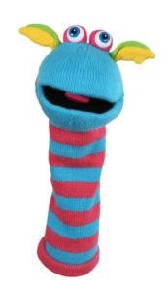 | Draw A View  Look out of your window and draw what you see…. | Show Kindness  Do something kind for someone. Can you pay them a compliment, make them something or help them with a task? | Mini Garden  Make a mini garden in an old tin or container using natural materials found in your garden/outdoor space or from when you are out doing your daily exercise.
Counting Songs  Search for BBC School Radio Nursery Rhymes and scroll down to Counting Songs.  Have fun singing along and learning all about numbers at the same time! | Kim’s Game  Collect 10 small, memorable items. Place them on a tray. Try and memorise the items. Close your eyes. Ask someone to cover them up and take one or two of the items away. Open your eyes and uncover the items. Can you guess what is missing? | Rainbow Colours  Draw or paint a rainbow. Try and arrange the colours in the correct order. Red, orange, yellow, green, blue, indigo and violet. | Fine Motor Skills  Keep practising these important skills. Can you fasten some buttons on a coat or cardigan? Can you pull up zips on trousers or boots? | Throwing and Catching  Use a ball outdoors or a soft toy indoors and gently practise your throwing and catching. How many can you do in a row before you drop the ball/soft toy?
Online resources: www.oxfordowl.co.uk www.familiesonline.co.uk www.parentclub.scot
www.topmarks.co.uk/maths-games/3-5-years/counting www.playscotland.org Percy the park keeper – youtube
SLCEarlyLearn – twitter page Jump Start Jonny Joe Wicks Cosmic Kids Yoga

Row, row, row your boat
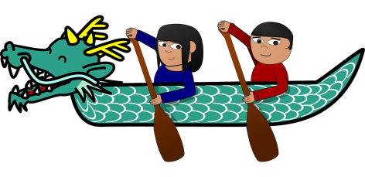

Row, row, row your boat
Gently down the stream
Merrily, merrily, merrily, merrily
Life is but a dream!

Row, row, row, your boat
Gently down the stream
If you see a crocodile
Don’t forget to scream!

