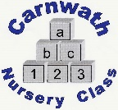
Carnwath Nursery Class
Home Learning – Week Beg: 25th May, 2020
We hope you all had a lovely, long weekend. Here are a few ideas for you to try this week. We miss you so much!
Our ‘Rhyme of the Week’ is ‘Five Little Monkeys’. Please find a copy attached below.
Oxford Owl  Visit the Oxford Owl Website and create a login to gain free access to lots of great e-books  www.oxfordowl.co.uk  They have added two new books called ‘Everybody Worries’ and ‘Winne and Wilbur Stay Home’ which are very relevant just now. | Make a Magic Potion  Make a solution of water, washing up liquid, vinegar, and food colouring. Add lots of magical, natural ingredients (from the garden or things you’ve collect when on your walk/cycle such as dandelions, petals, grass etc). Add Bicarboante of Soda and watch what happens! | Days of the Week  Practise saying the days of the week in order. Have a go at the months of the year too. YouTube has lots of videos and songs to help you.  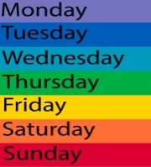 | Wellbeing Craft  Use a glass or plastic jar to create your own ‘Happiness Jar’. On little pieces of paper, write things down that you are looking forward to doing, once lockdown is over, and place them into your decorated jar.  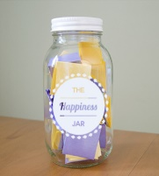 | Dressing Up  Play ‘Dressing Up’ with the costumes you have or with some borrowed hats, scarves, bags, shoes and jewellery from the adults in your house.  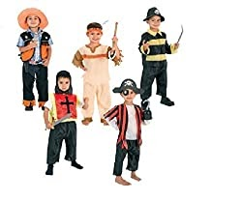
Hide and Seek  Hide your favourite cuddly toy somewhere in your house or garden for someone else to find. Tell them when they are hot (close by) or cold (far away).  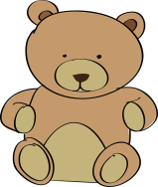 | Skittles  Collect 10 plastic bottles and have a go at setting up skittles in your garden with a ball. How many can you knock over? | Finger Gym  Give your fingers a work out by helping to hang up the washing. Maybe you could help to peg the socks?  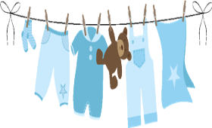 | Hand Eye Co-ordination  Use a colander and some uncooked spaghetti pasta. Place the colander upside down and push the pasta through all the holes. How long can you concentrate for?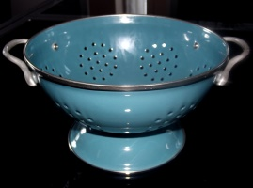 | 5 Little Monkeys  Use 5 of your cuddly toys to act out the rhyme ‘5 Little Monkeys’. You could change the words to five little animals/bears/dogs to match whatever toys you have chosen.  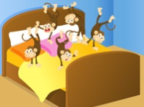
Five Little Monkeys
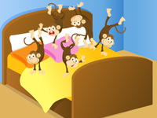

Five little monkeys jumping on the bed,
One fell off and bumped his head,
Mummy called the doctor and the doctor said,
No more monkeys jumping on the bed!

Four little monkeys jumping on the bed,
One fell off and bumped her head,
Mummy called the doctor and the doctor said,
No more monkeys jumping on the bed!

Three little monkeys……………..
Two little monkeys………………
One little monkey………………
No little monkeys……………

