P1 Virtual Sports Day Activities Grid
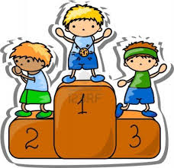
Make a circuit around your garden for these events.

Toilet Roll Race  Time how quickly you can run around your circuit with a toilet roll between your knees. | Tattie and Spoon Race  How quickly can you run around your circuit without dropping your tattie off the spoon? | The Cup Challenge  Fill up a cup of water and run around your circuit. How quickly can you do it without spilling any water? | Cushion Race  Time how quickly you can run around your circuit with a cushion balanced on your head. | Tattie and Spoon Race  How quickly can you run around your circuit without dropping your tattie off the spoon?
Time: | Time: | Time: | Time: | Time:

Wellie Toss  See how far you can toss a wellie. Measure the distance using your feet. | Tea Bag Challenge  Set up a cup/mug and stand between 1-3 metres away from it. How many throws does it take for the tea bag to land in the cup? | Shot Put  Using a toilet roll, see how far you can throw it. Measure the distance using your feet. | Target Practice  Set up three empty bottles about 3-5 metres away from you. Using a ball (or toilet roll), try to bowl the bottles over. How quickly can you get all three?
---------- of my feet. | ---------- tries. | ---------- of my feet. | Time:

Obstacle Course Challenge
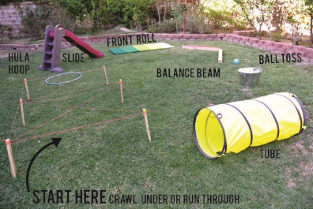
With an adult’s permission, design an obstacle course using objects in your house or garden.
Ask someone to take photos or video you as you complete it. How quickly can you do it?

Time:

