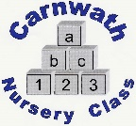
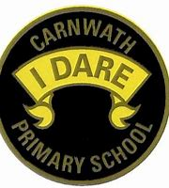
What is happening online this week?

Week Beg: Monday 20th April, 2020
Subject | Day | Time | Website
P.E. – Yoga  Cosmic Kids | Mon - Fri | N/A | www.cosmickids.com
P.E. – Yoga  Yogido | Mon - Fri | N/A | Facebook  Daily challenge. All the staff have been trained with Yogido
Literacy – Lucy’s in Lockdown | N/A | N/A | This is a follow up to Lucy’s Blue Day.  www.lucysblueday.com/product-page/lucy-s-in-lockdown  or find on Facebook
Music– Kate PIcken | N/A | N/A | Primary Music Activities on YouTube  Great musical activities
Maths – Carol Vorderman | Mon-Fri | N/A | www.themathsfactor.com
Technology –  Toy Theater – online building and art | N/A | N/A | https://toytheater.com
Comics – Dekko Comics | N/A | N/A | https://dekkocomics.com  Comics for a range of subjects e.g. maths - addition
Science – Scottish Wildlife Trust | Access everyday | N/A | https://scottishwildlifetrust.org.uk  watch wildlife online
News – CBBC Newsround | Mon – Fri | N/A | https://www.bbc.co.uk>newsround
Science – Zoo tours, safari parks | Access everyday | N/A | Chester Zoo  Blair Drummond Safari Park  Edinburgh Zoo

