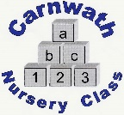
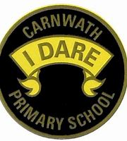
What is happening online this week?

Week Beg: Monday 27th April, 2020
Subject | Day | Time | Website
P.E. – Dance | N/A | N/A | Why not try Just Dance on YouTube or Zumba Kids has some great dances to follow.
Photography – Fun projects for children | N/A | N/A | 7 different projects for children to explore.  www.expertphotography.com/7-fun-photography-projects-children
Mixed lessons – BBC Bitesize.  20 minute lessons. Some from celebrities such as David Attenborough, Brian Cox and others | Mon-Fri | From 9am | See: BBC Bitesize daily or on BBC iplayer  For Curriculum for Excellence specific see: Learn at BBC Scotland
Maths –RBS MoneySense Mondays | Mon | 11:30 -12  12 – 12:30 | Ages 5-8 Coins and Notes  Ages 8-12 Budgeting  YouTube
Science/Eco –  Scottish SPCA home learning packs | N/A | N/A | www.scottishspca.org
Arts & Crafts | N/A | N/A | Lots of fun recycling art projects and ideas to draw every day.  www.adventure-in-a-box.com
Science – Weather with Good Morning Britain’s Laura Tobin | Access everyday | N/A | YouTube- Good Morning Britain Laura’s Lessons
Science, Engineering & Computing – Dr Chips Daily dose | Tues, Wed & Thurs | 10am | www.drchips.weebly.com

