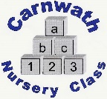
Carnwath Nursery Class
Home Learning – Week Beg: 20th April, 2020
A big hello to all of you. We are missing you lots and hope you are keeping safe and having lots of fun at home. Here are a few ideas of things you can do at home. Learning through play is the best so have fun playing and learning together.
Make a Magic Wand  Gather some sticks from your garden or if you are out your allocated walk Paint them all different colours. You can even tie on some string or old ribbon and have a magic wand. | Minibeast Hunt  Go and be an exciting explorer and see what insects and bugs live in your garden. Lift logs or stones to see who is living below but remember to put them back where they belong. | Water Play  We all know our children love water play. Fill the bath or sink with water and get different containers. Talk about being full and empty. If the adults are feeling adventurous add some dinosaurs or make a junk model boat | Scavenger Hunt  This is great fun. Make a list of things you need to collect either in your house or outside. Who can collect them all? Why not try a rainbow hunt? Find something red one day, orange the next and so on. | Milk Bottle Crafts  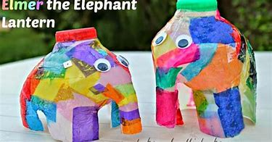  Cut the bottom off and cover in different coloured paper to make and Elmer elephant. Or how about cutting a hole out the front and making into a fairy house or a superhero headquarters. They also make great bird feeders.
Obstacle Course  Make your own obstacle course in the house or in your garden. Weave in and out plant pots, big stones or teddy bears, jump over sticks or pens. How about having two buckets or containers and see how fast you can move your toys from one bucket to the other. | Drawing  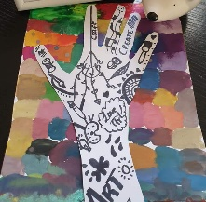  Draw round your hand and draw lots of doodles or lines on the paper to make cool hand art. | A Teddy Bear Picnic  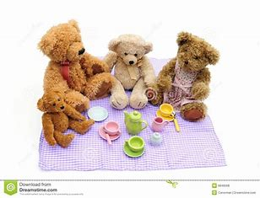  Set up your own picnic for your toys. You could even write invitations to invite them along and help prepare a snack for the people in your house. | Building a Tower  See who in your family can build the biggest tower using lego bricks or any other materials you like. How many blocks did you use? How did you get it to balance? | Counting Fun  Help count out the cutlery at meal times, count stones in the garden, count our pens to draw. Can you match the numbers?
Online resources: www.oxfordowl.co.uk www.familiesonline.co.uk www.parentclub.scot
www.topmarks.co.uk/maths-games/3-5-years/counting www.playscotland.org Percy the park keeper – youtube
SLCEarlyLearn – twitter page Jump Start Jonny Joe Wicks Cosmic Kids Yoga
Stay safe and adhere to all government guidelines.

