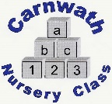
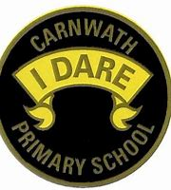
What is happening online this week?

Week Beg: Monday 4th May, 2020
Subject | Day | Time | Website
P.E. | N/A | N/A | Why not try Kidz Bop dance tutorials on YouTube.  Or Les Mills activities at www.lesmills.com/uk/workouts/kids-classes
French | N/A | N/A | French with Mr Innes on YouTube.  Fantastique five minute videos teaching about different vocabulary such as pets, colours and jobs.
Music – ABC Music | Mon-Fri | New classes added by 10am | www.abcmusic.org.uk
Music – BBC Ten Pieces | Mon-Fri | N/A | Making music at home. www.bbc.co.uk/teach/ten-pieces
Science – BP Educational Service | N/A | N/A | www.bpes.bp.com  Lots of fun STEM activities.
Science – Let’s Go Live with Maddie and Greg | N/A | N/A | Maddie Moate on YouTube from Cbeebies
Road Safety – Go Safe with Ziggy | Access everyday | N/A | Great for younger children. It explains social distancing and gives ideas for things to do when you are out walking.  www.roadsafety.scot
H.W.B. – Yoga Ed | Access everyday | N/A | Great for mindfulness.  Yoga Ed on YouTube – classes are in different age groups.

