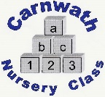
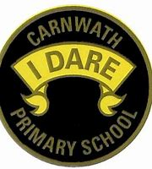
What is happening online this week?

Week Beg: Monday 11th May, 2020
Subject | Day | Time | Website
P.E. | Mon-Fri | 9am | Joe Wicks  Try 10 minute Disney Shake up’s on www.nhs.co.uk
Mathematics – White Rose Maths | N/A | N/A | Good website with activities for children to work through on various mathematical concepts.
Music – Royal Scottish National Orchestra | New video every Wed | N/A | #RSNO Challenge at www.rsno.org.uk  Challenge include Musical Bottles and Tuneful Glasses.
Literacy– National Literacy Trust | N/A | N/A | Great resources in the Family Zone at www.literacytrust.org.uk
Literacy – Axel Scheffler’s Coronavirus Book | N/A | N/A | The illustrator of books like The Gruffalo has written a free downloadable book. See www.axelscheffler.com
Literacy – PBS – Read Along Monday’s with Michelle Obama | New on Monday’s | N/A | PBS on YouTube
Science – Blackshall’s Virtual Wildlife | N/A | N/A | CBBC website or on YouTube
Science – The Great Indoors by the Scouts | N/A | N/A | www.scouts.org.uk

