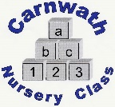
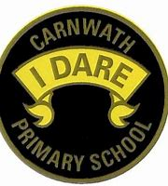
What is happening online this week?

Week Beg: Monday 18th May, 2020
Subject | Day | Time | Website
P.E. | Mon-Fri | 9am | Joe Wicks  Hearts Radio’s Ashley Roberts is doing dance classes every Monday at 10am also.
Mathematics – Maths on Toast | Every day but new tasks on a Monday | N/A | Great resources or tasks to do at home.  https://www.mathsontoast.org.uk/monday-maths-fun-day/
Music – Scottish Opera | New video every Monday | N/A | Learn the Opera Fever. 5 songs with a new one every Monday. This is one we have performed in school before.  www.scottishopera.org.uk
Literacy– Everybody Worries Book | N/A | N/A | Great book written by Jon Burgerman  www.oxfordowl.co.uk
French – Lingobox Learning | New video every Thurs | 11:30am | Fun videos to learn vocabulary e.g. Disco workout on numbers to 100.
Music– Mr Craigheads Music Blog | N/A | N/A | https://mrcraigheadmusic184794772.  wordpress.com

