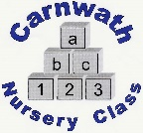
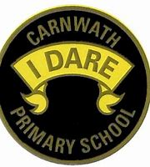
What is happening online this week?

Week Beg: Monday 1st June, 2020
Subject | Day | Time | Website
P.E. | Mon-Fri | 9am | Joe Wicks
P.E. –  Team GB | Every day | N/A | Great resources provided by team GB. Lots of challenges including games to try and mascots to design.  www.getset.co.uk
Music – Music with Mr McNulty | Weekly lessons | N/A | Music lessons added every week.
Mathematics– Carol Voderman | N/A | N/A | www.themathsfactor.com
Health and Wellbeing – Feelings stories and activities | N/A | N/A | www.emmachaill.ie/inside-feelings  A lovely book and activities about dealing with feelings at this challenging time.
Science– Theatre of Science | New every Tues | N/A | New lessons every week. Last weeks was an experiment on ‘earthquakes, tsunamis and landslides’.  See YouTube – Theatre of Science
Science/Eco – Learning through Landscapes | New activities every week. | N/A | Some super activities every week to keep you busy. One of my favourite ideas last week was about ‘creating a critter’.  www.ltl.org.uk

