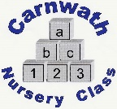
Carnwath Nursery Class
Home Learning – Week Beg: 1st June, 2020
We are missing you all so much and all the staff want to say a big hello. This week we have chosen the nursery rhyme ‘Five Little Speckled Frogs’. A copy is included below.
Mini Sports Day  Try out some sports day games. You could do the potato and spoon race or use jumpers as hurdles. | Chalk Drawings  If you have some chalk try writing on the ground or pavement. You could make wiggly snakes or writing some letters from your name. | Water Play  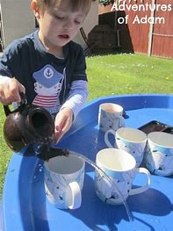  Fill up the sink or a basin and find lots of different containers. You could do this outside in the sun and set up a pretend tea party with cups. | Cereal Box Jigsaw  Get an adult to help you cut up a cereal box to make it into a tricky jigsaw puzzle.  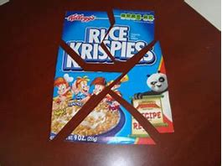 | Soft Toy Puppet Show  Collect some soft toys or teddies and use them to re-tell your favourite story. Or maybe use a story you have made up when you have been at home.
Weighing Station  Collect some different items from the kitchen and sort them into what you think is heavy and light. If you have some scales you could ask an adult to you see if you were correct. | Leaf Pictures  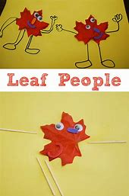  Collect some leaves then stick them on to a piece of paper. Draw on arms and legs to make people or animals. | Space X Rocket  Ask an adult to show you the video from YouTube of the rocket launch from the weekend. Can you build your own rocket? | Playdough Fun  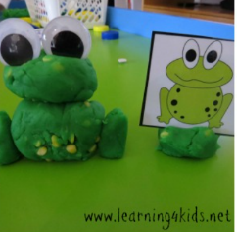  Can you make some frogs using playdough? Draw a speckled log for them to sit on and practice our rhyme. | Frogs  Research the life cycle of a frog.  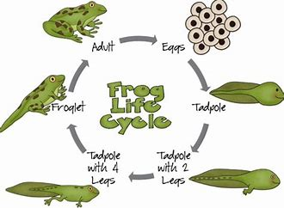
Online resources: www.oxfordowl.co.uk www.familiesonline.co.uk www.parentclub.scot
www.topmarks.co.uk/maths-games/3-5-years/counting www.playscotland.org Percy the park keeper – YouTube
SLCEarlyLearn – twitter page Jump Start Jonny Joe Wicks Cosmic Kids Yoga
Stay safe and adhere to all government guidelines.

