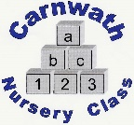
Carnwath Nursery Class
Home Learning – Week Beg: 4th May, 2020
We are missing you all so much and all the staff want to say a big hello. This week we would like to start a focus on a different nursery rhyme this week. This week we have chosen Mary had a Little Lamb a copy is included below.
Cutting Skills  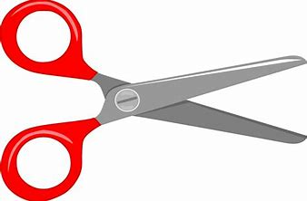  Have fun using scissors to cut up leaves and grass to make a lovely home for some bugs and beasties to live in. Make sure to stay safe using scissors. | Make a Lamb  Just like our rhyme of the week how can you make a lamb? Will you use cotton wool or cut one out of paper? You could also look for lambs when you are out your allocated walk. | Cardboard City  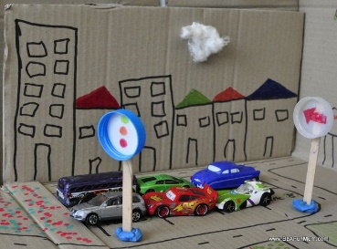  Using old carboard boxes and with some help from an adult why not create your own cardboard city. | Number Walk  It is fun to look for numbers all around us. You could go a number hunt in your house or when you are outside. | Lego Patterns  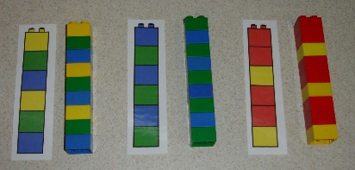  Can you make a pattern using lego bricks or any other toys. You could use coloured pencils to draw a pattern too.
Mindfulness  Practice some breathing techniques to help you keep nice and calm. Breathe in is like smelling a flower and breathe out is like blowing a leaf. | Stone Drawing  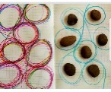  Sit some stones on a piece of paper and using a pen or pencil draw around the stones in different directions. Alternatively, you could use a stick and draw around them in the ground. | Story Talk  Talk to a sibling or adult about your favourite story. What is your favourite character? Can you change the ending of the story? | Space Writing  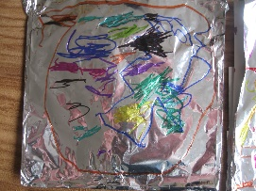  Ask an adult if you can have a little bit of tin foil. Using crayons, pens or paint make lines and spots all over to make a new planet. | Jumping  Practice jumping. Can you jump across the room? Can you hop? How about trying some star jumps? Maybe your siblings or adults can join in.
Online resources: www.oxfordowl.co.uk www.familiesonline.co.uk www.parentclub.scot
www.topmarks.co.uk/maths-games/3-5-years/counting www.playscotland.org Percy the park keeper – youtube
SLCEarlyLearn – twitter page Jump Start Jonny Joe Wicks Cosmic Kids Yoga
Stay safe and adhere to all government guidelines.

