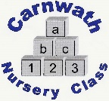
Carnwath Nursery Class
Home Learning – Week Beg: 18th May, 2020
We are missing you all so much and all the staff want to say a big hello. This week we have chosen 1,2,3,4,5 Once I Caught a Fish Alive as our nursery rhyme. A copy is included below.
Draw a Fish  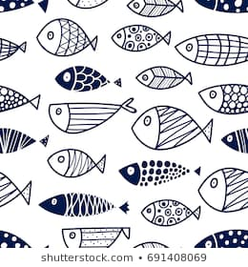  Can you draw a big fish and practice your pencil hold by adding in scales or different lines. | Pizza Parts  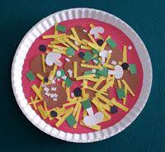  Using a paper plate or a big circle of paper, design your own pizza. Then cut it into different parts to share with your family. What topping will you add? | Helping Hands  How many times can you help around the house this week? Can you make your own bed, peg up the washing or wash the dishes. | Superhero Workout  Why not try some Avengers workouts on YouTube. Great fun and everyone in the family can get involved and keep nice and healthy. | Make a Dandelion  Collect lots of dandelions then glue a big circle on a piece of paper. Stick the dandelions on, then make into a lion.  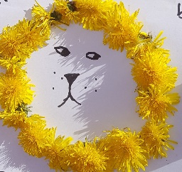
Handprint Drawing  Draw around your hand and see if you can make it into fun animals. | Treasure Hunt  Go on a treasure hunt around your house, your garden or even on a walk. Find things that are bigger or smaller than something from home e.g. things that are bigger than a pencil. | Animal Facts  What is your favourite animal? Can you see if an adult or an older brother or sister could help you research 3 fun facts about it. | Play Schools  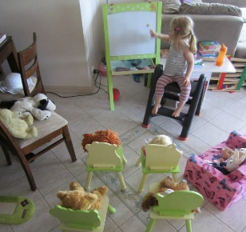  Why not set up a school at home? Maybe your family could be the pupils. | Book Bug  This week is Book Bugs 10th Anniversary. Go to their website for lots of fun activities.  https://www.scottishbooktrust.com  /bookbug  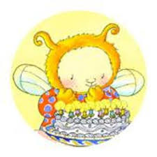
Online resources: www.oxfordowl.co.uk www.familiesonline.co.uk www.parentclub.scot
www.topmarks.co.uk/maths-games/3-5-years/counting www.playscotland.org Percy the park keeper – youtube
SLCEarlyLearn – twitter page Jump Start Jonny Joe Wicks Cosmic Kids Yoga
Stay safe and adhere to all government guidelines.

