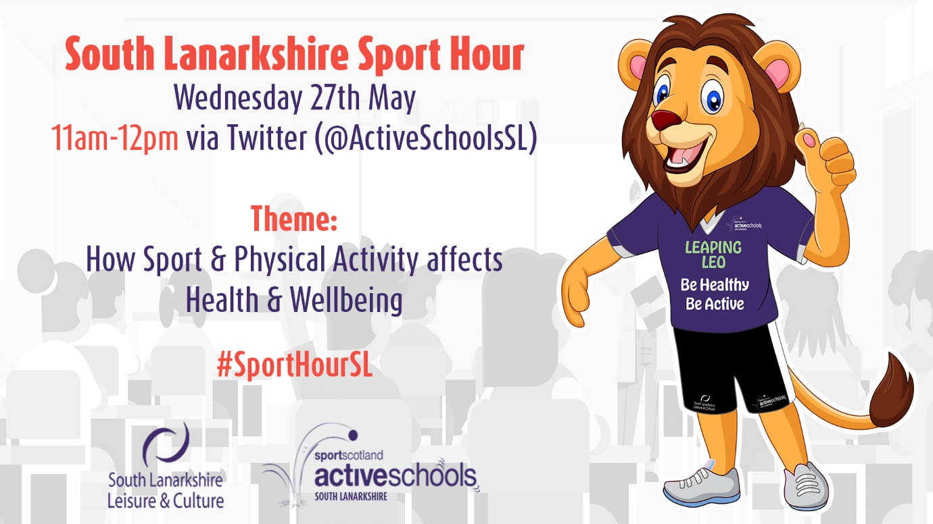

SOUTH LANARKSHIRE SPORT HOUR | SCHOOL INFORMATION

Dear School Sport Contact,

I hope that you and your family are keeping safe and well during this time of uncertainty. Your team of Active Schools Coordinators would like to invite your school and your wider community to participate in the upcoming South Lanarkshire Sport Hour!

What is the South Lanarkshire Sport Hour?
The South Lanarkshire Sport Hour is an initiative by the Active Schools Coordinators designed at raising awareness of a range of themes, such as Sport & Physical Activity, Mental Health in Sport, Sport in the Community, Volunteers in Sport and many more.

This month’s theme is ‘How does Sport & Physical Activity affect Health & Wellbeing’.

How do we participate in the South Lanarkshire Sport Hour?
There are a number of ways in which you can participate in the South Lanarkshire Sport Hour. The event will take place on Twitter via the South Lanarkshire Active Schools account (@ActiveSchoolsSL).

Between 11am-12pm on Wednesday 27th May we will announce a series of questions relating to this month’s theme. We would then ask that participants ‘Tweet’ their answers using the hashtag #SportHourSL and tagging @ActiveSchoolsSL.

Some ways you can engage as a school-
- A designated teacher can take part on behalf their school from their designated school account
- Teachers can take part from their own accounts and even tweet their own classes response (questions will be published days in advance)
- Parent/carers can submit an answer on behalf of their child (for children below the minimum age requirement for Twitter)
- Pupils can use their own accounts to Tweet answers (for pupils above the minimum age requirement for Twitter)

Additional information:
We would love to have your support in helping to raise awareness of this event. Accompanied with this letter will be a ‘We’re taking part! Are you?!’ graphic. Please feel free to share this on your social media platforms and newsletters. If using Twitter, please tag @ActiveSchoolsSL and hashtag #SportHourSL.

Should you have any questions about the upcoming South Lanarkshire Sport Hour, please contact your local Active Schools Coordinator.

Yours sincerely,

Josh Anderson
Active Schools Coordinator
Stonelaw Learning Community
South Lanarkshire Leisure & Culture

07795455323
josh.anderson@southlanarkshireleisure.co.uk

