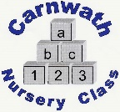
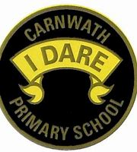
What is happening online this week?

Week Beg: Monday 8st June, 2020
Subject | Day | Time | Website
P.E. | Mon-Fri | 9am | Joe Wicks
P.E. –  Team GB | Every day | N/A | Great resources provided by team GB. Lots of challenges including games to try and mascots to design.  www.getset.co.uk
Eco – World Ocean Day | Mon 8th | N/A | https://worldoceanday.school/  Have a rockpool ramble or learn how to dive like a dolphin in these live lessons.
Mathematics– Carol Voderman | N/A | N/A | www.themathsfactor.com
Science– Children’s Astronomy | Tues | 3pm | Interactive talk about finding asteroids.  http://www.youtube.com/watch?v=IVIPfrvmX6g
Science/Eco – Learning through Landscapes | New activities every week. | N/A | Some super activities every week to keep you busy.  www.ltl.org.uk
Science – Edinburgh Zoo | N/A | N/A | Edinburgh Zoo are running a campaign called Wild About June encouraging you to do something wild at home. Lots of great ideas.  https://www.edinburghzoo.org.uk/education/

