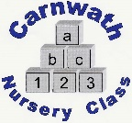
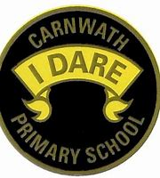
What is happening online this week?

Week Beg: Monday 15st June, 2020
Subject | Day | Time | Website
P.E. | Mon-Fri | 9am | Joe Wicks
P.E. –  Team GB | Every day | N/A | Great resources provided by team GB. Lots of challenges including games to try and mascots to design.  www.getset.co.uk
Eco –  One Planet Picnic | Wed 17th June | N/A | https://www.keepscotlandbeautiful.org/one-planet-picnic.  A One Planet Picnic is a picnic that is good for you and good for the planet. It is a fun way to make your food and drink choices environmentally friendly. Look at the step by step guide on the site above.
Eco –  World Largest Lesson | Tues 16th June | 4pm | https://worldslargestlesson.globalgoals.org/worlds-largest-lesson-live-follow-up-activities/
Mathematics– Carol Voderman | N/A | N/A | www.themathsfactor.com
Music –  Good Morning Mrs Jones | New lessons every week | N/A | These are fab interactive music lessons that you can’t help joining in with.  https://www.youtube.com/ channel/UC3ApBh5FKckAVbHAz3TCQOg
Science/Eco – Learning through Landscapes | New activities every week. | N/A | Some super activities every week to keep you busy.  www.ltl.org.uk

