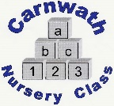
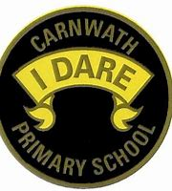
What is happening online this week?

So here is our last weekly update, well done everyone for staying safe and well,
When we started learning from home, we thought it would only be for a short spell.
But we’ve made it to the Summer holidays so everybody cheer,
You’ve worked so hard during a very mixed up year.
Maths lessons, virtual zoo tours and science with all the tricks,
However, I don’t think the teacher’s legs will ever be the same after weeks of Joe Wicks.
It may be a little different when we see you in the new school year,
But we tackle everything at Carnwath without any fear.
Just remember we are all so proud of everyone one of you,
So log off, switch off and go enjoy your holidays too
Week Beg: Monday 22st June, 2020
Subject | Day | Time | Website
P.E. | Mon & Wed | 9am | Joe Wicks – go on give it a go for one last week!
Science – RSPB WildArt | N/A | N/A | Why not enter this great WildArt competition.  See www.rspb.org.uk
Guiness World Records – at home | N/A | N/A | Come on let’s have a school full of record breakers.  Most socks put on one foot in 30 seconds, most trampoline seat drops in 30 seconds, tallest zigzag lego structure in 30 seconds.  https://kids.guinnessworldrecords.com/activities/try-this-at-home

