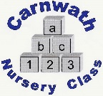
Carnwath Nursery Class
Home Learning – Week Beg: 15th June, 2020
Here are a few ideas of things to keep you busy at home this week. We are missing you all very much. Stay safe and keep washing your hands!
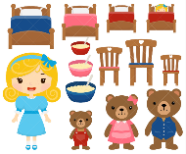
Our ‘Rhyme of the Week’ is ‘Teddy Bear, Teddy Bear’. Please find a copy attached below.
Animal Walk  Inside or out, encourage your child to slither like a snake, hop like a frog, gallop like a horse, or walk like a bear on all fours. Skills developed: hopping, galloping. | Road safety  Don’t forget about the importance of road safety. Most of our children are aware of Ziggy. Here is the Ziggy website, with stories, songs and activities linked to road safety. | Picnic  On Wed across the world people will take part in the One Planet Picnic. You could have a picnic too. See if you can use sustainable products that are locally produced. | Bring Me  Ask the children to bring you 4 apples, 1 orange. Gather anything you have by number. | Book Bug Session  https://www.scottishbooktrust.com/  articles/online-bookbug-session-teddy-bears-picnic  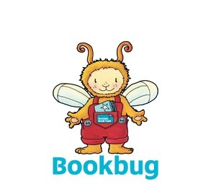
Streamer dance Give the children ribbons or scarves and put on some music for them to dance to with their streamers (try this activity using music of varying types and speeds). | Light play  Use a torch to create the shadow of a well-known object onto a board, screen or a clear bit of wall. Make a dark den with a blanket and some chairs. Use the torches to find hidden objects. Use sweet wrappers to change the colour of the light. | Simon Says  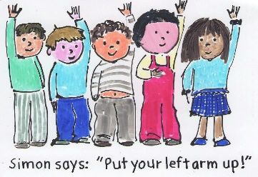  Play Simon says; make it as easy or hard as you need to | Remember This Talk about a real trip from the past, for example, a walk to the shops, a trip to the park, a holiday. Try to remember lots of details (what was the weather like, sights and smells, the order of events). Talk about trips you would like to take in the future. | Goldilocks Maths –Watch/Read the story of Goldilocks and the Three Bears. Talk about who is the tallest, shortest, oldest etc. How many bowls were there? Can you find 3 different sized bowls in your kitchen and allocate them to a bear. You might use your cuddly toys to represent characters. Can you find 3 spoons, 3 chairs, etc.?
Online resources: www.oxfordowl.co.uk www.familiesonline.co.uk www.parentclub.scot
www.topmarks.co.uk/maths-games/3-5-years/counting www.playscotland.org Percy the park keeper – youtube

