We’re Going on a Journey
We’re going on a journey,
It’s going to be a big one.

Uh oh an Angel!

We’re going to have a baby.
He will be the son of God.

Mary and Joseph walked and they walked and the walked.

Uh oh no room at the inn.

We’re going to have a baby,
The baby was born in the stable.

Uh oh the Angel spoke to the shepherds.

We’re going on a journey,
It’s going to be a big one.

The shepherds walked and they walked and they walked.

We’re here to see the baby,
He’s asleep in the manger.

Uh oh a bright star shone for the wise men.

We’re going on a journey,
It’s going to be a big one.

The three wise men walked and they walked and they walked.

We’re here to see the baby,
We bring Gold, Frankincense and Myrrh.

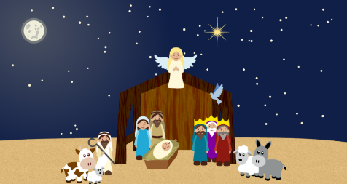
We’re going on a journey,
It’s going to be a big one.

The birth of baby Jesus.

